Model I EX 요구사항

* Customer 관련 :회원가입, 로그인, 정보수정, 로그아웃, 회원리스트보기(*페이징처리)
* 고객센터(파일첨부게시판) – 글쓰기, 답변글쓰기, 글목록(페이징추가), 글수정, 글 삭제
* 도서등록, 도서리스트보기(페이징), 도서상세보기
* 로그인한 사람만 도서등록을 할 수 있고, 글쓰기가 가능하다
* 글수정은 내가 쓴 글만 수정 가능하다.
* 글 쓰기는 로그인 이후에만 가능하다.
* 글삭제는 삭제비밀번호만 알면 본인이 쓴 글이 아니어도, 로그인 전이여도 삭제가 가능하다.
* header의 gnb와 footer의 배경색은 #003300

실행화면 캡쳐

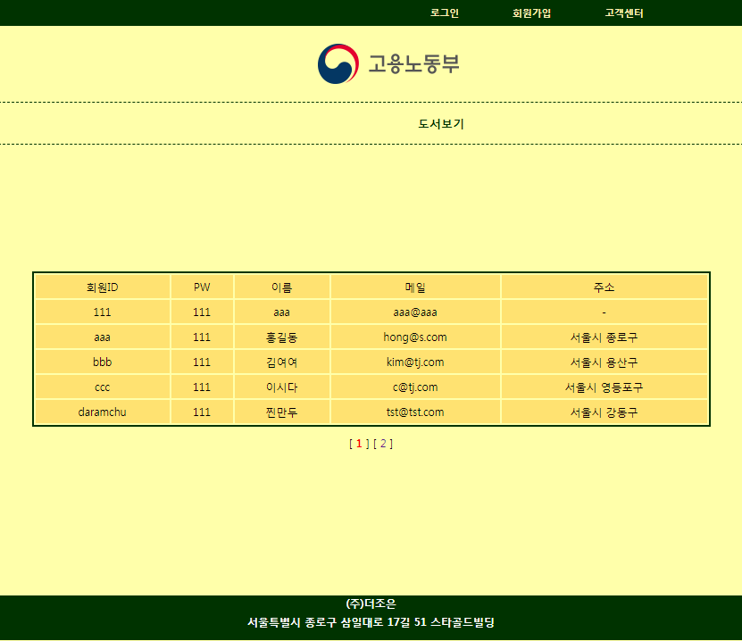 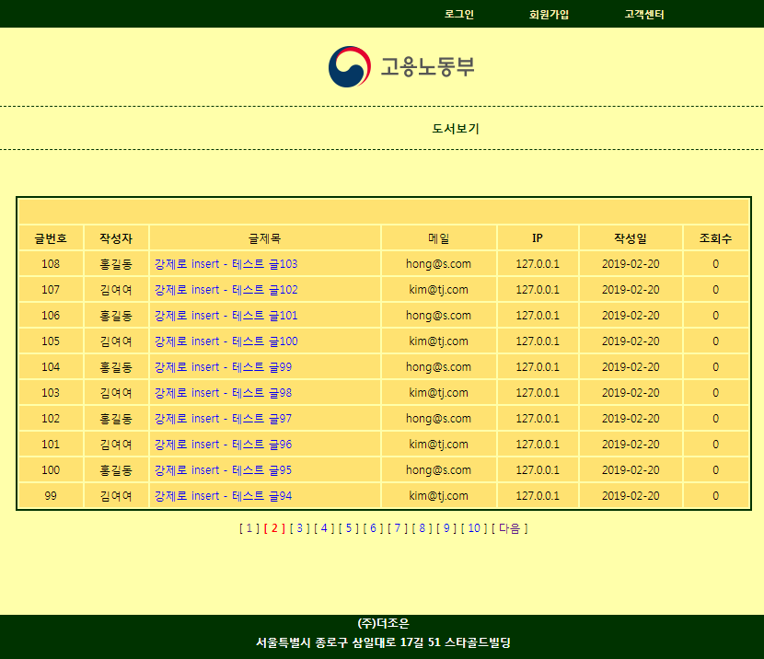

**답변글 가능한**

**파일 첨부 게시판**

**(글쓰기 버튼은로그인 이후에만 나타남)**

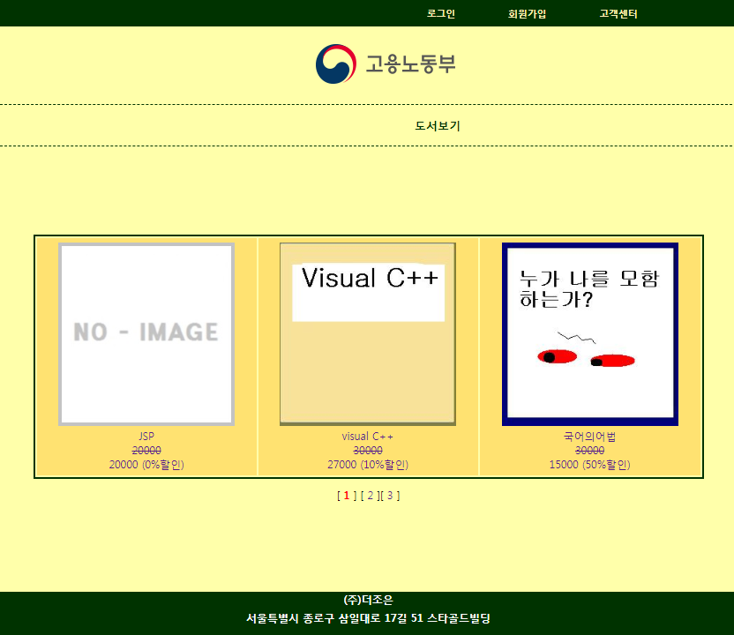 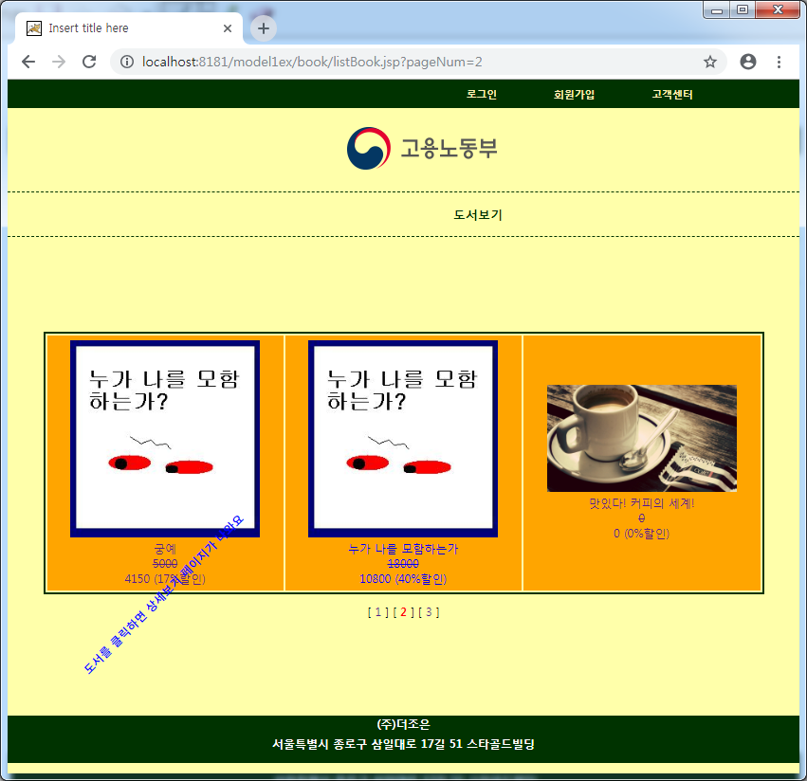

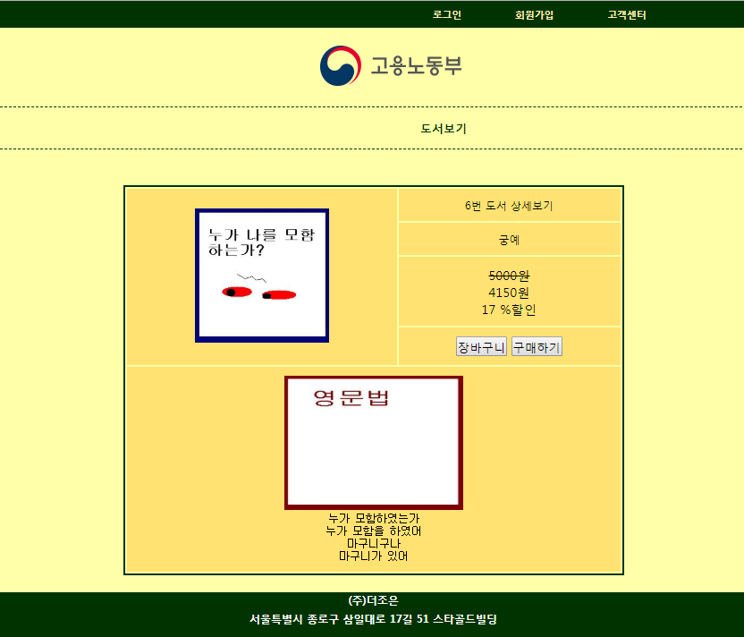 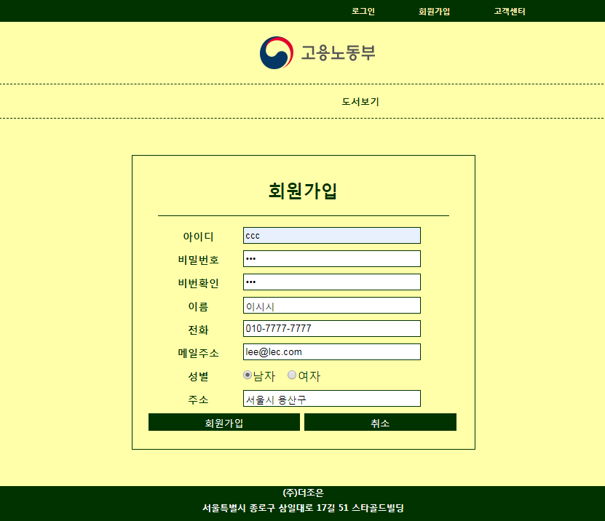

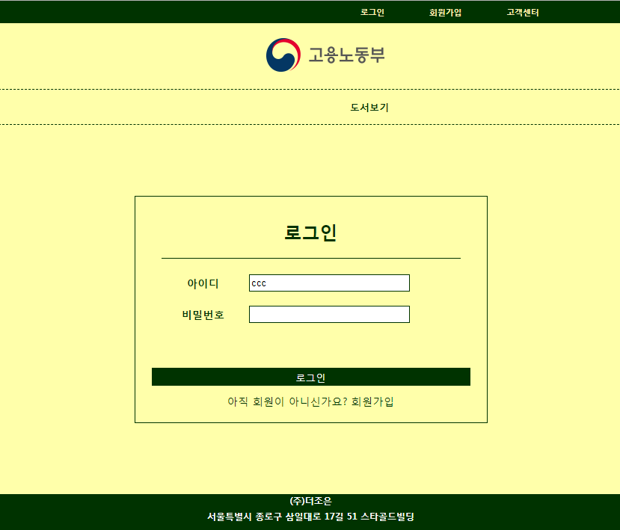 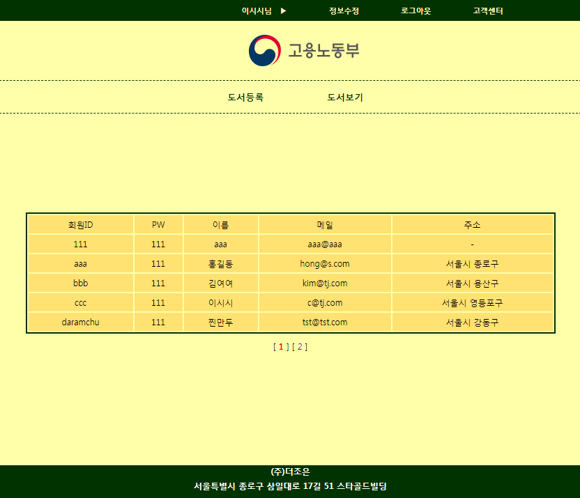

로그인 이후에 생김(session)

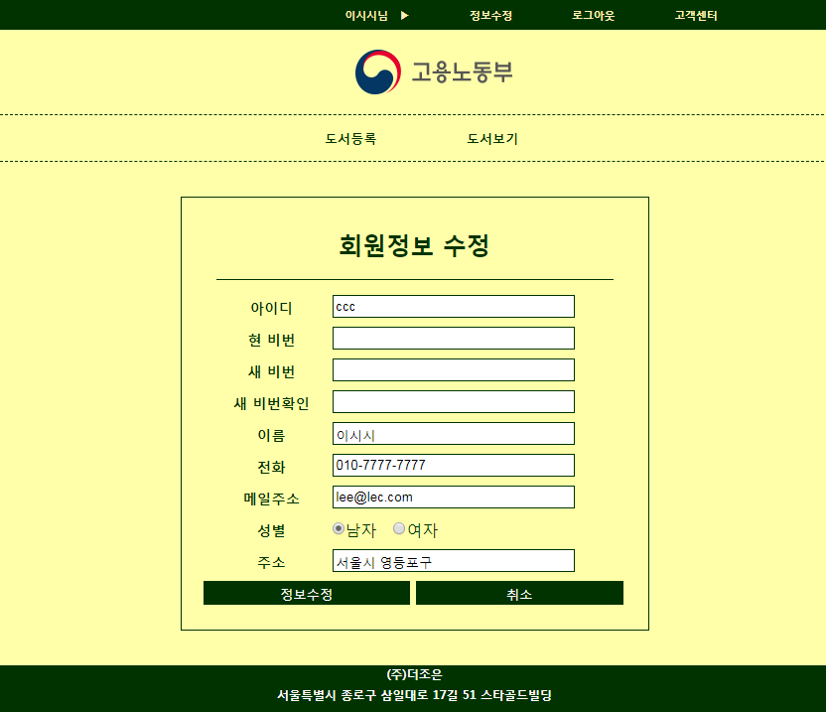 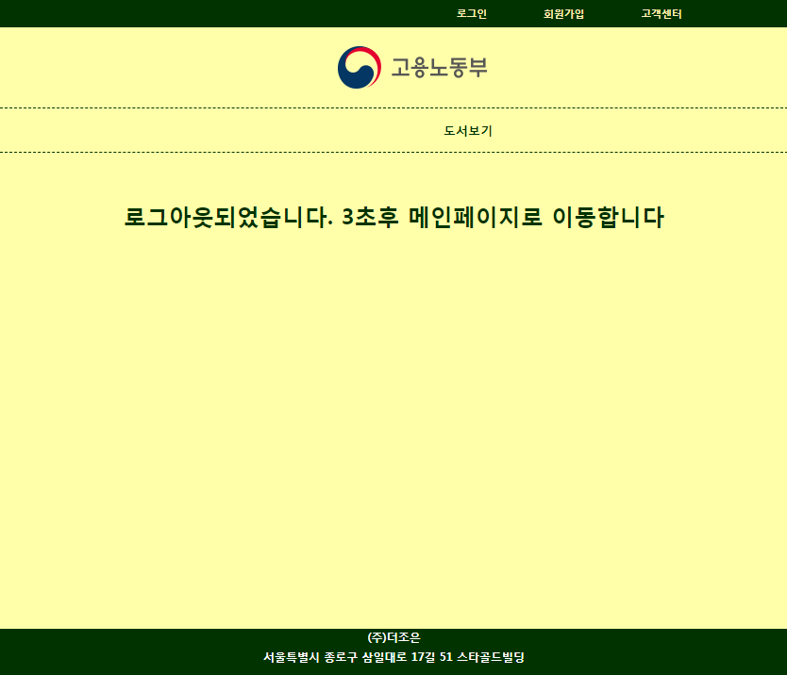

 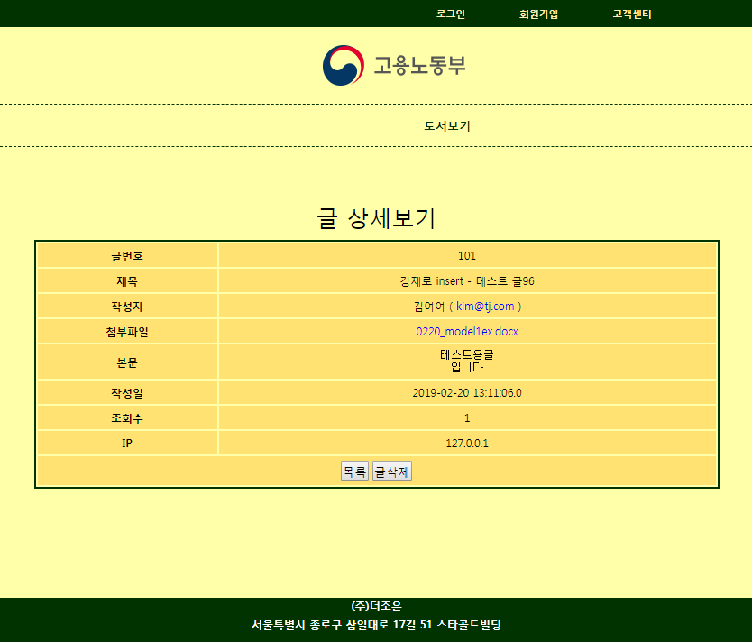

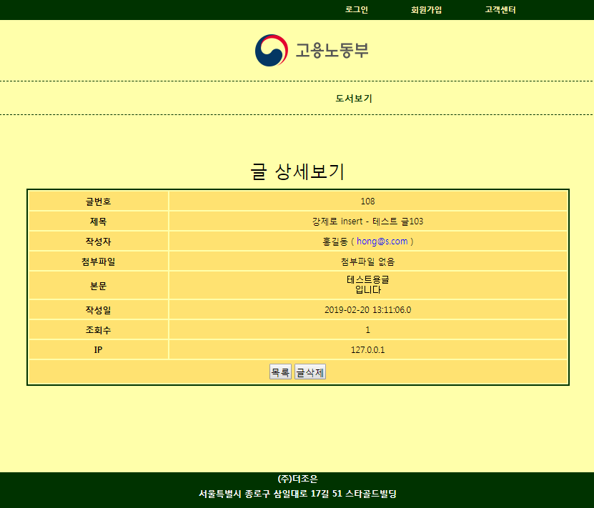 ←첨부파일이 없을 경우 “첨부파일 없음”라고 출력

로그인 한 후 고객센터 게시판 : 수정(본인 글만 수정), 답변(로그인 후), 삭제(비번알면 타인글도 로그인 전도 가능).

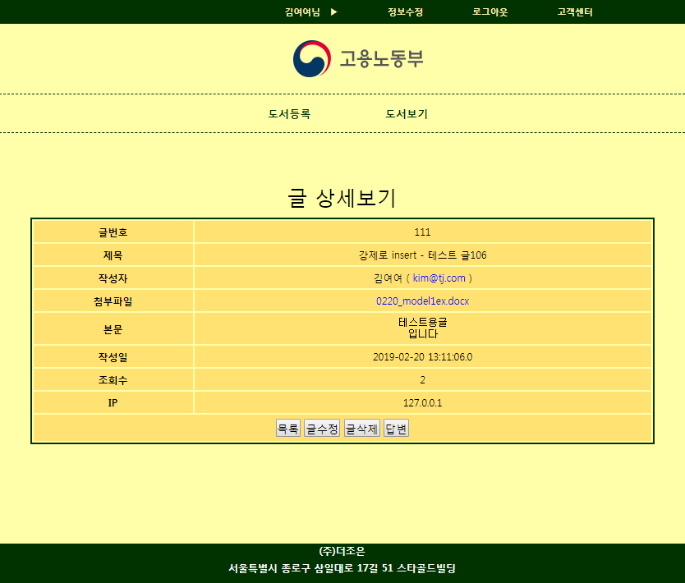 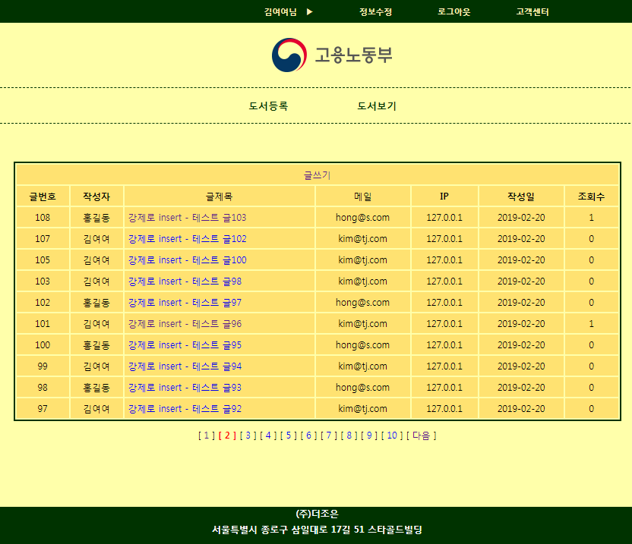

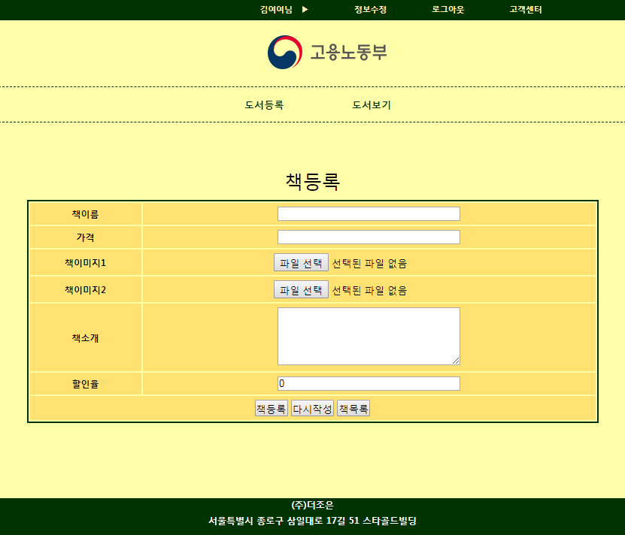 ← 도서등록은 로그인 후에만 가능

프로젝트 구성요소

* DTO3개(BookDto,CustomerDto,FileboardDto), DAO 3개(BookDao,CustomerDao,FileboardDao)는 src폴더에 아래의 폴더는 WebContent폴더에
* img 폴더 - 이 프로그램에서 필요한 이미지들(로고, hot.gif, level.gif, re.gif)
* main 폴더 - footer.jsp
* header.jsp
* main.jsp(첫화면)
* customer폴더 - joinForm.jsp
  + - * + joinPro.jsp
        + loginForm.jsp
        + loginPro.jsp
        + logout.jsp
        + modifyForm.jsp
        + modifyPro.jsp
* book폴더 - bookList.jsp
  + - * bookRegister.jsp
      * bookRegisterPro.jsp
      * bookdetail.jsp
* bookImg폴더 - 도서등록시 업로드할 파일들이 저장될 폴더
* fileboard폴더 – fboardList.jsp
  + - * + fboardContent.jsp
        + fboardDeleteForm.jsp
        + fboardDeletePro.jsp
        + fboardUpdateForm.jsp
        + fboardUpdatePro.jsp
        + fboardWriteForm.jsp
        + fboardWritePro.jsp
* fileboardUpload 폴더- 파일첨부게시판에서 첨부한 파일들이 저장될 폴더
* 그 외 css

**(WebContent/main/footer.jsp)**

<%@ page language=*"java"* contentType=*"text/html; charset=UTF-8"*

pageEncoding=*"UTF-8"*%>

<!DOCTYPE html>

<html>

<head>

<meta charset=*"UTF-8"*>

<title>Insert title here</title>

<style>

**body**{background-color: *#ffffaa*;}

**footer**{height: *50px*; background-color: *#003300*;}

**footer** *#footer_info*{

color:*white*;

font-weight: *bold*;

font-size: *12px*;

text-align: *center*;

}

**footer** *#footer_info* **p**{margin: *5px auto*;}

</style>

</head>

<body>

<footer>

<div id=*"footer_info"*>

<p>(주)조은회사</p>

<p>서울특별시 아무구 몰라로 98길 76 조은빌딩</p>

</div>

</footer>

</body>

</html>

**(WebContent/css/header.css)**

@charset *"UTF-8"*;

*{padding:*0*; margin: *0*;}

**header** {

background-color: *#ffffaa*; font-size: *9pt*;

}

**header** **a** {text-decoration: *none*; font-weight: *bold*;}

**header** **li** { list-style: *none*;}

**header** *.gnb*{width: *100%*; background-color: *#003300*;}

**header** *.gnb* **ul** {

overflow: *hidden*;

width:*700px*;

height: *30px*;

line-height: *30px*;

margin: *0* *auto*;

}

**header** *.gnb* **ul** **li** { float: *right*; margin-right: *30px*;}

**header** *.gnb* **a** {

color : *#FFF0B5*;

font-size: *0.9em*;

display: *block*;

padding-left:*15px*;

padding-right:*15px*;

}

**header** *.logo*{

width:*120px*; text-align:*center*;

margin: *20px* *auto*;

cursor: *pointer*;

}

**header** *.lnb* {

width: *100%*;

border-top: *1px* *dashed* *#003300*;

border-bottom: *1px* *dashed* *#003300*;

}

**header** *.lnb* **ul**{

overflow: *hidden*;

width:*300px*;

margin: *0* *auto*;

}

**header** *.lnb* **ul** **li** {

margin: *5px*;

float:*right*;

padding:*5px* *40px*;

line-height: *25px*;

}

**header** *.lnb* **a** {

height:*1.1em*;

color: *#003300*;

font-size:*1.1em*;

margin-bottom: *20px*;

}

**(WebContent/main/header.jsp)**

<%@ page language=*"java"* contentType=*"text/html; charset=UTF-8"*

pageEncoding=*"UTF-8"*%>

<% String conPath = request.getContextPath(); %>

<!DOCTYPE html>

<html>

<head>

<meta charset=*"UTF-8"*>

<title>Insert title here</title>

<link href=*"*<%=conPath %>*/css/header.css"* rel=*"stylesheet"*>

</head>

<body>

<header>

<div class=*"gnb"*>

<%**if**(session.getAttribute("validMember")==**null**){ %>

<!-- 우측 메뉴부터 고객센터, 회원가입, 로그인 메뉴 -->

<ul>

<li><a href=*"*<%=conPath %>*/fileboard/fboardList.jsp"*>고객센터</a></li>

<li><a href=*"*<%=conPath %>*/customer/joinForm.jsp"*>회원가입</a></li>

<li><a href=*"*<%=conPath %>*/customer/loginForm.jsp"*>로그인</a></li>

</ul>

<%} %>

<%**if**(session.getAttribute("validMember")!=**null**){ %>

<!-- 우측부터 고객센터, 로그아웃, 정보수정, 고객이름 -->

<ul>

<li><a href=*"*<%=conPath %>*/fileboard/fboardList.jsp"*>고객센터</a></li>

<li><a href=*"*<%=conPath %>*/customer/logout.jsp"*>로그아웃</a></li>

<li><a href=*"*<%=conPath %>*/customer/modifyForm.jsp"*>정보수정</a></li>

<li><a><%=session.getAttribute("cname") %>님 &nbsp; ▶</a></li>

</ul>

<%} %>

</div>

<div class=*"logo"* onclick="location.href='../main/main.jsp'">

<img src=*"*<%=conPath %>*/img/logo.png"*>

</div>

<div class=*"lnb"*>

<ul>

<li><a href=*"*<%=conPath %>*/book/bookList.jsp"*>도서보기</a></li>

<% **if**(session.getAttribute("validMember")!=**null**){//로그인해야나와%>

<li><a href=*"*<%=conPath %>*/book/bookRegister.jsp"*>도서등록</a></li>

<% } %>

</ul>

</div>

</header>

</body>

</html>

**(WebContent/css/style.css)**

@charset *"UTF-8"*;

**body** {

background-color: *#fff0B5*;

font-size: *12px*;

}

**table** {border: *2px* *solid* *#003300*; width:*95%*; margin: *10px* *auto*;}

**table** **tr** { background-color: *#FFE271*; }

**table** **tr***:hover* { background-color: *orange*;

cursor: *pointer*;

}

**td,** **th** {text-align: *center*; padding:*5px*; }

**caption** {font-size: *25px*; padding:*10px*;}

**h2, b**{text-align: *center*; color:*red*;}

**a** { text-decoration: *none*; }

*.left*{text-align: *left*;}

*.paging* {text-align: *center*;}

*.currentPage* {color:*red*; font-weight: *bold*;}

**(WebContent/main/main.jsp - 첫화면)**

<%@page import=*"com.tj.model1ex.dto.CustomerDto"*%>

<%@page import=*"com.tj.model1ex.dao.CustomerDao"*%>

<%@page import=*"java.util.ArrayList"*%>

<%@ page language=*"java"* contentType=*"text/html; charset=UTF-8"*

pageEncoding=*"UTF-8"*%>

<!DOCTYPE html PUBLIC "-//W3C//DTD HTML 4.01 Transitional//EN" "http://www.w3.org/TR/html4/loose.dtd">

<html>

<head>

<meta http-equiv=*"Content-Type"* content=*"text/html; charset=UTF-8"*>

<title>Insert title here</title>

<link href=*"../css/style.css"* rel=*"stylesheet"*>

<style>

*#content* {

width: *800px*; height:*400px*;

margin: *100px auto 0px*;

}

</style>

</head>

<body>

<jsp:include page=*"../main/header.jsp"*/>

<div id=*"content"*>

<br><br>

<table>

<tr><td>회원ID</td><td>PW</td><td>이름</td><td>메일</td><td>주소</td></tr>

<%

String pageNum = request.getParameter("pageNum");

**if**(pageNum == **null**) pageNum="1";

**int** currentPage = Integer.parseInt(pageNum);

**int** PAGESIZE = 5, BLOCKSIZE=3;

**int** startRow = (currentPage-1)*PAGESIZE +1;

**int** endRow = startRow + PAGESIZE-1;

CustomerDao cDao = CustomerDao.getInstance();

ArrayList<CustomerDto> customers = cDao.getlistCustomer(startRow, endRow);

**if**(customers.size()==0){

out.print("<tr><td colspan='5'>가입한 회원이 없습니다</td></tr>");

}**else**{

**for**(CustomerDto c : customers){

out.print("<tr><td>"+c.getCid()+"</td>");

out.print("<td>"+c.getCpw()+"</td>");

out.print("<td>"+c.getCname()+"</td>");

out.print("<td>"+c.getCemail()+"</td>");

out.print("<td>"+(c.getCaddress()==**null**? "-":c.getCaddress ())+"</td></tr>");

}//for

}//if

%>

</table>

<div class=*"paging"*>

<%**int** totCnt = cDao.getCustomerCnt(); // DB에 있는 회원수

**int** pageCnt = (**int**)Math.ceil((**double**)totCnt/PAGESIZE); // 페이지갯수

**int** startPage = ((currentPage-1)/BLOCKSIZE)*BLOCKSIZE +1;

**int** endPage = startPage + BLOCKSIZE -1;

**if**(endPage>pageCnt)

endPage = pageCnt;

**if**(startPage>BLOCKSIZE){%>

[ <a href=*"main.jsp?pageNum=*<%=startPage-1%>*"*>이전</a> ]

<%}

**for**(**int** i=startPage ; i<=endPage ; i++){

**if**(i==currentPage){%>

[ <span class=*"currentPage"*><%=i %></span> ]

<%}**else**{ %>

[ <a href=*"main.jsp?pageNum=*<%=i%>*"*><%=i %></a> ]

<%}

}

**if**(endPage<pageCnt){%>

[ <a href=*"main.jsp?pageNum=*<%=endPage+1%>*"*>다음</a> ]

<%} %>

</div>

</div>

<jsp:include page=*"../main/footer.jsp"*/>

</body>

</html>

**(WebContent/index.jsp)**

<%@ page language=*"java"* contentType=*"text/html; charset=UTF-8"*

pageEncoding=*"UTF-8"*%>

<!DOCTYPE html>

<html>

<head>

<meta charset=*"UTF-8"*>

<title>Insert title here</title>

</head>

<body>

<% response.sendRedirect("main/main.jsp"); %>

</body>

</html>

**(WebContent/fileboard/insert60.jsp)**

<%@page import=*"com.tj.model1ex.dto.FileBoardDto"*%>

<%@page import=*"com.tj.model1ex.dao.FileBoardDao"*%>

<%@ page language=*"java"* contentType=*"text/html; charset=UTF-8"*

pageEncoding=*"UTF-8"*%>

<%FileBoardDao fbDao = FileBoardDao.getInstance();

FileBoardDto fbDto = **new** FileBoardDto();

**for**(**int** i=0 ; i<60 ; i++){

// writeForm.jsp에서 받아왔던 것

**if**(i%2==0)

fbDto.setCid("bbb");

**else** **if**(i%2==1)

fbDto.setCid("aaa");

fbDto.setFsubject("강제로 insert - 테스트 글"+i);

**if**(i%2==0)

fbDto.setFfilename("0220_model1ex.docx");

**else**

fbDto.setFfilename(**null**);

fbDto.setFcontent("테스트용글\n입니다");

fbDto.setFpw("11");

// writePro.jsp에서 추가한 내용

fbDto.setFip(request.getRemoteAddr());

fbDto.setFnum(0);

fbDto.setFref(0);

fbDto.setFre_level(0);

fbDto.setFre_step(0);

**int** result = fbDao.insertFileBoard(fbDto);

System.out.println(result==FileBoardDao.SUCCESS? i+"번째성공":

i+"번째 실패");

}

response.sendRedirect("fboardList.jsp");

%>

<!DOCTYPE html PUBLIC "-//W3C//DTD HTML 4.01 Transitional//EN" "http://www.w3.org/TR/html4/loose.dtd">

<html>

<head>

<meta http-equiv=*"Content-Type"* content=*"text/html; charset=UTF-8"*>

<title>Insert title here</title>

</head>

<body>

</body>

</html>

**(WebContent/fileboard/fboardList.jsp)**

<%@page import=*"com.tj.model1ex.dto.FileBoardDto"*%>

<%@page import=*"com.tj.model1ex.dao.FileBoardDao"*%>

<%@page import=*"java.util.ArrayList"*%>

<%@ page language=*"java"* contentType=*"text/html; charset=UTF-8"*

pageEncoding=*"UTF-8"*%>

<!DOCTYPE html PUBLIC "-//W3C//DTD HTML 4.01 Transitional//EN" "http://www.w3.org/TR/html4/loose.dtd">

<html>

<head>

<meta http-equiv=*"Content-Type"* content=*"text/html; charset=UTF-8"*>

<title>Insert title here</title>

<link href=*"../css/style.css"* rel=*"stylesheet"*>

<style>

*#content* {

width: *800px*; height:*415px*;

margin: *50px auto 40px*;

}

</style>

</head>

<body>

<jsp:include page=*"../main/header.jsp"*/>

<div id=*"content"*>

<table style="width:*100%*;">

<tr><td colspan=*'7'*>&nbsp;

<% **if**(session.getAttribute("customer")!=**null**){%>

<a href=*"fboardWriteForm.jsp"*>글쓰기</a>

<%} %>&nbsp;

</td></tr>

<tr><th>글번호</th><th>작성자</th><td>글제목</td><td>메일</td>

<th>IP</th><th>작성일</th><th>조회수</th>

</tr>

<% String pageNum = request.getParameter("pageNum");

**if**(pageNum==**null**){ // pageNum이 파라미터로 안 들어왔으면 1page로

pageNum = "1";

}

**int** currentPage = Integer.parseInt(pageNum);

**final** **int** PAGESIZE = 10, BLOCKSIZE=10;

**int** startRow = (currentPage-1) * PAGESIZE + 1;

**int** endRow = startRow + PAGESIZE -1;

//

FileBoardDao fbDao = FileBoardDao.getInstance();

**int** totCnt = fbDao.getFileBoardCnt(); // 글갯수 리턴

**if**(totCnt==0){

out.print("<tr><td colspan='7'>데이터가 없습니다</td></tr>");

}**else**{

ArrayList<FileBoardDto> dtos = fbDao.getlistFileBoard(startRow, endRow);

**for**(**int** i=0 ; i<dtos.size() ; i++){

out.print("<tr><td>"+dtos.get(i).getFnum()+"</td>");

out.print("<td>"+dtos.get(i).getCname()+"</td>");

// 글제목은 인기글 icon추가, 글제목을 클릭하면 상세보기 추가

out.print("<td class='left'>");

**if**(dtos.get(i).getFre_step()>0){//들여쓰기하기

**int** width = dtos.get(i).getFre_level()*20;

// 들여쓰기 효과

out.print("<img src='../img/level.gif' width='"+width+"'"+" height='10'>");

out.print("<img src='../img/re.gif'>");

}

**if**(dtos.get(i).getFhit()>10){

out.print("<img src='../img/hot.gif'>");

}

out.print("<a href='fboardContent.jsp?fnum=");

out.print(dtos.get(i).getFnum()+"&pageNum="+pageNum+"'>");

out.print(dtos.get(i).getFsubject()+"</a></td>");

out.print("<td>"+dtos.get(i).getCemail()+"</td>");

out.print("<td>"+dtos.get(i).getFip()+"</td>");

out.print("<td>"+dtos.get(i).getFrdate().toString().substring(0, 10)+"</td>");

out.print("<td>"+dtos.get(i).getFreadcount()+"</td>");

}

}

%>

</table>

<div class=*"paging"*>

<% // 페이지 갯수(pageCnt)=마지막페이지 / 글갯수(totCnt)

**int** pageCnt = (**int**)Math.ceil((**double**)totCnt/PAGESIZE);

**int** startPage = ((currentPage-1)/BLOCKSIZE)*BLOCKSIZE +1;

**int** endPage = startPage + BLOCKSIZE - 1;

**if**(endPage>pageCnt){

endPage = pageCnt;

}

**if**(startPage>BLOCKSIZE){

out.print(" [ <a href='fboardList.jsp?pageNum="+(startPage-1)+"'>이전</a> ] ");

}

**for**(**int** i=startPage ; i<=endPage ; i++){

**if**(i==currentPage){

out.print("<font color='red'><b> [ "+i+" ] </b></font>");

}**else**{

out.print(" [ <a href='fboardList.jsp?pageNum="+i+"'>"+i+"</a> ] ");

}

}

**if**(endPage<pageCnt){

out.print(" [ <a href='fboardList.jsp?pageNum="+(endPage+1)+"'>다음</a> ] ");

}

%>

</div>

</div>

<jsp:include page=*"../main/footer.jsp"*/>

</body>

</html>

**(WebContent/fileboard/fboardContent.jsp)**

<%@page import=*"com.tj.model1ex.dto.FileBoardDto"*%>

<%@page import=*"com.tj.model1ex.dao.FileBoardDao"*%>

<%@ page language=*"java"* contentType=*"text/html; charset=UTF-8"*

pageEncoding=*"UTF-8"*%>

<!DOCTYPE html PUBLIC "-//W3C//DTD HTML 4.01 Transitional//EN" "http://www.w3.org/TR/html4/loose.dtd">

<html>

<head>

<meta http-equiv=*"Content-Type"* content=*"text/html; charset=UTF-8"*>

<title>Insert title here</title>

<link href=*"../css/style.css"* rel=*"stylesheet"*>

<style>

*#content* {

width: *800px*; height:*400px*;

margin: *50px auto*;

}

</style>

</head>

<body>

<jsp:include page=*"../main/header.jsp"*/>

<div id=*"content"*>

<% String pageNum = request.getParameter("pageNum");

**int** fnum = Integer.parseInt(request.getParameter("fnum"));

FileBoardDao fbDao = FileBoardDao.getInstance();

fbDao.hitUp(fnum);// 조회수 하나 증가

FileBoardDto fbDto = fbDao.getFileBoardOneLine(fnum);

%>

<table>

<caption>글 상세보기</caption>

<tr><th>글번호</th><td><%=fbDto.getFnum() %></td></tr>

<tr><th>제목</th><td><%=fbDto.getFsubject()%></td></tr>

<tr><th>작성자</th>

<td><%=fbDto.getCname() %>

( <a href=*"mailto:*<%=fbDto.getCemail()%>*"*><%=fbDto.getCemail()%></a> )

</td></tr>

<tr><th>첨부파일</th>

<td><%**if**(fbDto.getFfilename()==**null**){

out.println("첨부파일 없음");

}**else**{

out.println("<a href='../fileboardUpload/"+fbDto.getFfilename()+"' target='_blank'>"+fbDto.getFfilename()+"</a>");

}

%>

</td>

</tr>

<tr><th>본문</th>

<td><pre><%=fbDto.getFcontent() %></pre></td>

</tr>

<tr><th>작성일</th><td><%=fbDto.getFrdate() %></td></tr>

<tr><th>조회수</th><td><%=fbDto.getFhit() %></td></tr>

<tr><th>IP</th><td><%=fbDto.getFip() %></td></tr>

<tr><td colspan=*"2"*>

<button onclick=*"location.href='fboardList.jsp?pageNum=*<%=pageNum%>*'"*>목록</button>

<% // 본인이 쓴 글이 아니면 수정버튼 안 나오게 함

String sessionCid = (String)session.getAttribute("cid");

String fbDtoCid = fbDto.getCid();

**if**(fbDtoCid.equals(sessionCid)){ %>

<button

onclick=*"location.href='fboardUpdateForm.jsp?fnum=*<%=fnum%>*&pageNum=*<%=pageNum%>*'"*>

글수정</button>

<% } %>

<button

onclick=*"location.href='fboardDeleteForm.jsp?fnum=*<%=fnum%>*&pageNum=*<%=pageNum%>*'"*>

글삭제</button>

<% // 로그인하지 않으면 답변버튼이 안 나온다

**if**(session.getAttribute("validMember")!=**null**){%>

<button

onclick=*"location.href='fboardWriteForm.jsp?fnum=*<%=fnum %>*&pageNum=*<%=pageNum %>*'"*

>답변</button>

<% } %>

</td>

</tr>

</table>

</div>

<jsp:include page=*"../main/footer.jsp"*/>

</body>

</html>